OPERATING SYSTEMS AND SYSTEMS PROGRAMMING

Sec:- 2

Name:- Sai Sowseelya Vedula
RollNo:- 2520030260

Practical 8
8-A
Develop a program using malloc(), calloc(), realloc(), and free(). Monitor memory allocation behavior and identify memory leaks using Valgrind.
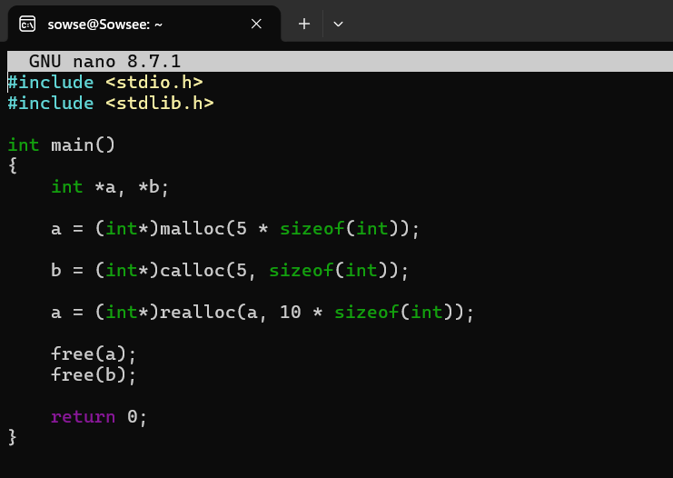
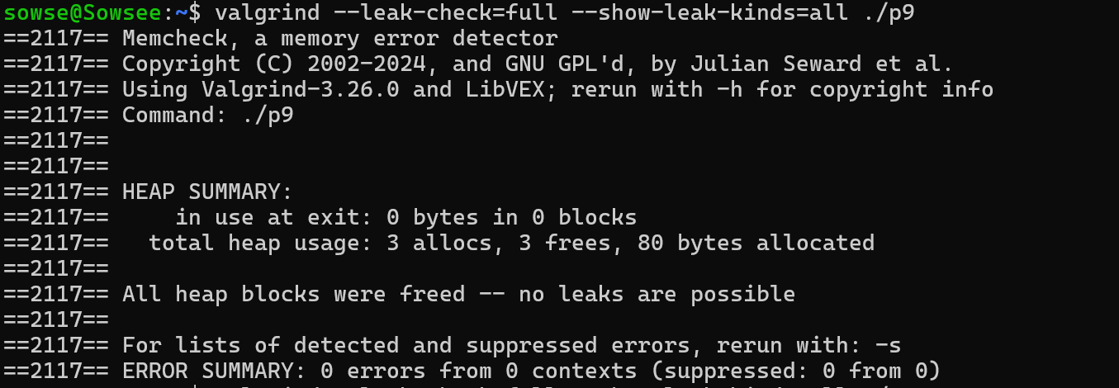

8-B

Copy-on-Write Program
Develop a program that demonstrates Copy-on-Write behavior after a fork(). Analyze memory usage before and after modifying data in the child process.
